|  |  |  |  |  |
| --- | --- | --- | --- | --- |
|  | Shri Vile Parle Kelavani Mandal's  **INSTITUTE OF TECHNOLOGY**  **DHULE (M.S.)**  **DEPARTMENT OF COMPUTER ENGINEERING** | | |  |
| **Subject :** Web Technology Lab |  | Remark |
| **Name :** Pavan Bhika patil | **Roll No. :**55 |
| **Class :** S.Y.Comp **Batch :** S4 | **Division:** B |
| **Expt. No. :**10 **Date :** 19/05/2025 |  | Signature |
| **Title:** Write a PHP program to sort the student records which are stored in the database using ascending/descending order**.** |  |

CREATE TABLE IF NOT EXISTS students (  
    id INT AUTO_INCREMENT PRIMARY KEY,  
    name VARCHAR(100),  
    grade INT  
);

INSERT INTO students (name, grade) VALUES  
('Atharve', 85),  
('harsh', 78),  
('Chaitali', 92),  
('Diksha', 88);                                                                                                                                                                                                                  <?php  
$host = 'localhost';  
$user = 'root';  
$password = '';   
$database = 'school';

$conn = new mysqli($host, $user, $password, $database);  
if ($conn->connect_error) {  
    die("Connection failed: " . $conn->connect_error);  
}  
$sort_field = isset($_GET['field']) ? $_GET['field'] : 'id';  
$sort_order = isset($_GET['order']) ? $_GET['order'] : 'ASC';  
$allowed_fields = ['id', 'name', 'grade'];  
$allowed_orders = ['ASC', 'DESC'];

if (!in_array($sort_field, $allowed_fields)) {  
    $sort_field = 'id';  
}

if (!in_array($sort_order, $allowed_orders)) {  
    $sort_order = 'ASC';  
}  
$sql = "SELECT * FROM students ORDER BY $sort_field $sort_order";  
$result = $conn->query($sql);  
?>  
<!DOCTYPE html>  
<html>  
<head>  
<title>Sort Students</title>  
</head>  
<body>  
<h2>Student Records</h2>  
<form method="GET" action="">  
<label for="field">Sort by:</label>  
<select name="field" id="field">  
<option value="id">ID</option>  
<option value="name">Name</option>  
<option value="grade">Grade</option>  
</select>

        <select name="order" id="order">  
<option value="ASC">Ascending</option>  
<option value="DESC">Descending</option>  
</select>

        <input type="submit" value="Sort">  
</form>

    <table border="1" cellpadding="10" style="margin-top: 20px;">  
<tr>  
<th>ID</th>  
<th>Name</th>  
<th>Grade</th>  
</tr>  
<?php  
        if ($result && $result->num_rows > 0) {  
            while($row = $result->fetch_assoc()) {  
                echo "<tr>  
<td>{$row['id']}</td>  
<td>{$row['name']}</td>  
<td>{$row['grade']}</td>  
</tr>";  
            }  
        } else {  
            echo "<tr><td colspan='3'>No student records found.</td></tr>";  
        }  
        ?>  
</table>  
</body>  
</html>

<?php  
$conn->close();  
?>

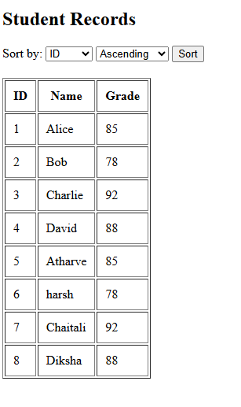

c